NCSA - Release 1

Date: Feb 23, 2025

1. Retention per URL:

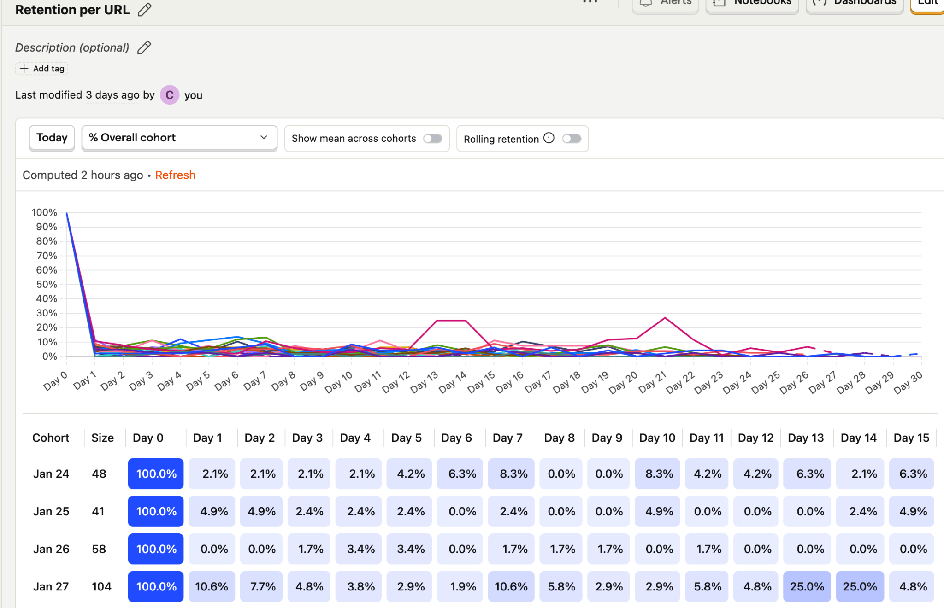

Insights:

*The analysis of this graph can be used to identify sticky users.*

Description:

1. Graph Overview:
   * Illustrates user revisit rates over 30 days
   * X-axis: Tracking period (30 days)
   * Y-axis: Revisit rate (0%-100%)
2. Line Representation:
   * Each line shows revisit probability for users who first logged in on a specific date
   * Tracks these users over the subsequent 30 days
3. User Calculation Method:
   * Only accounts for new logged-in users each day in 30 days
   * Excludes previously logged-in users
4. Benefits of this Approach:
   * Demonstrates retention patterns for different user acquisition dates
   * Helps identify highly sticky user groups
   * Allows analysis of factors affecting user revisits
5. Strategic Applications:
   * Enables comparison of revisit curves from different dates
   * Facilitates evaluation of user acquisition strategies
   * Aids in developing targeted measures to improve user retention rates

The graph shows an average user revisit rate of about 5% within 30 days, with significant fluctuations on certain dates. Notably, new users who logged in on January 27th exhibited a markedly higher revisit rate than other dates, peaking at 27%. Out of 104 users who first logged in on that day, 19 revisited more than 5 times within 30 days.

Moreover, even users with lower revisit rates from the January 27th cohort showed a pattern of multiple revisits on the same day, suggesting possible participation in the same course or social connections. These observations highlight the anomalous user behavior on specific dates, providing direction for in-depth analysis of user retention and engagement, and helping to understand potential factors influencing user revisits.

2. Views per page

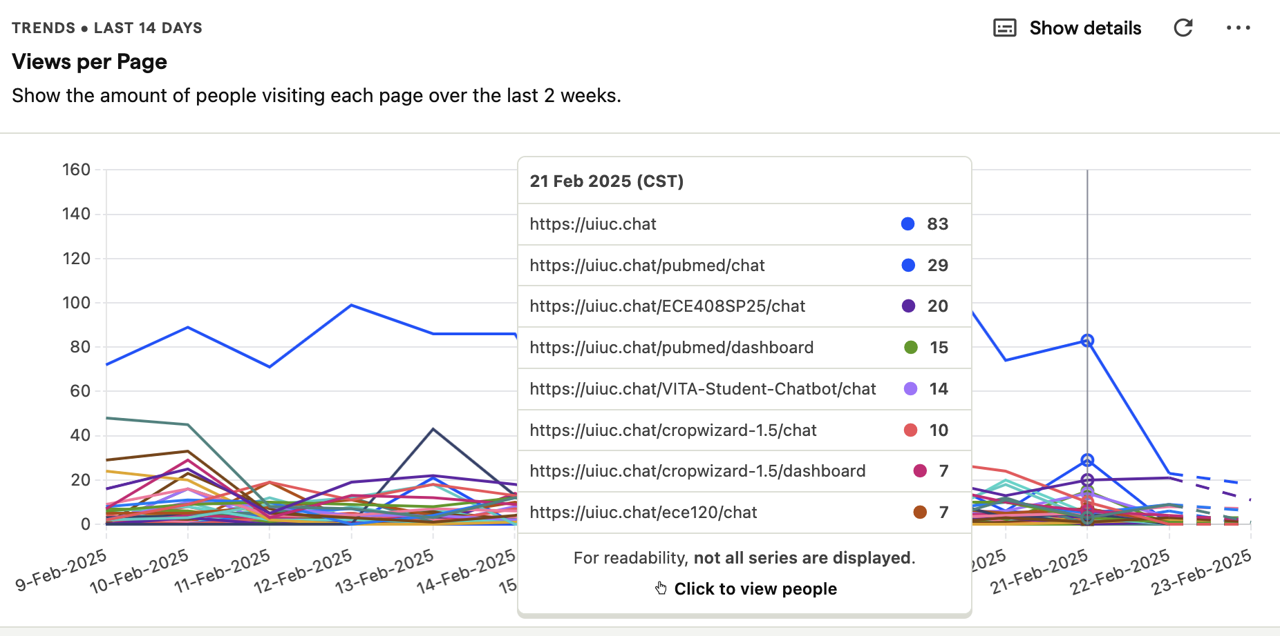

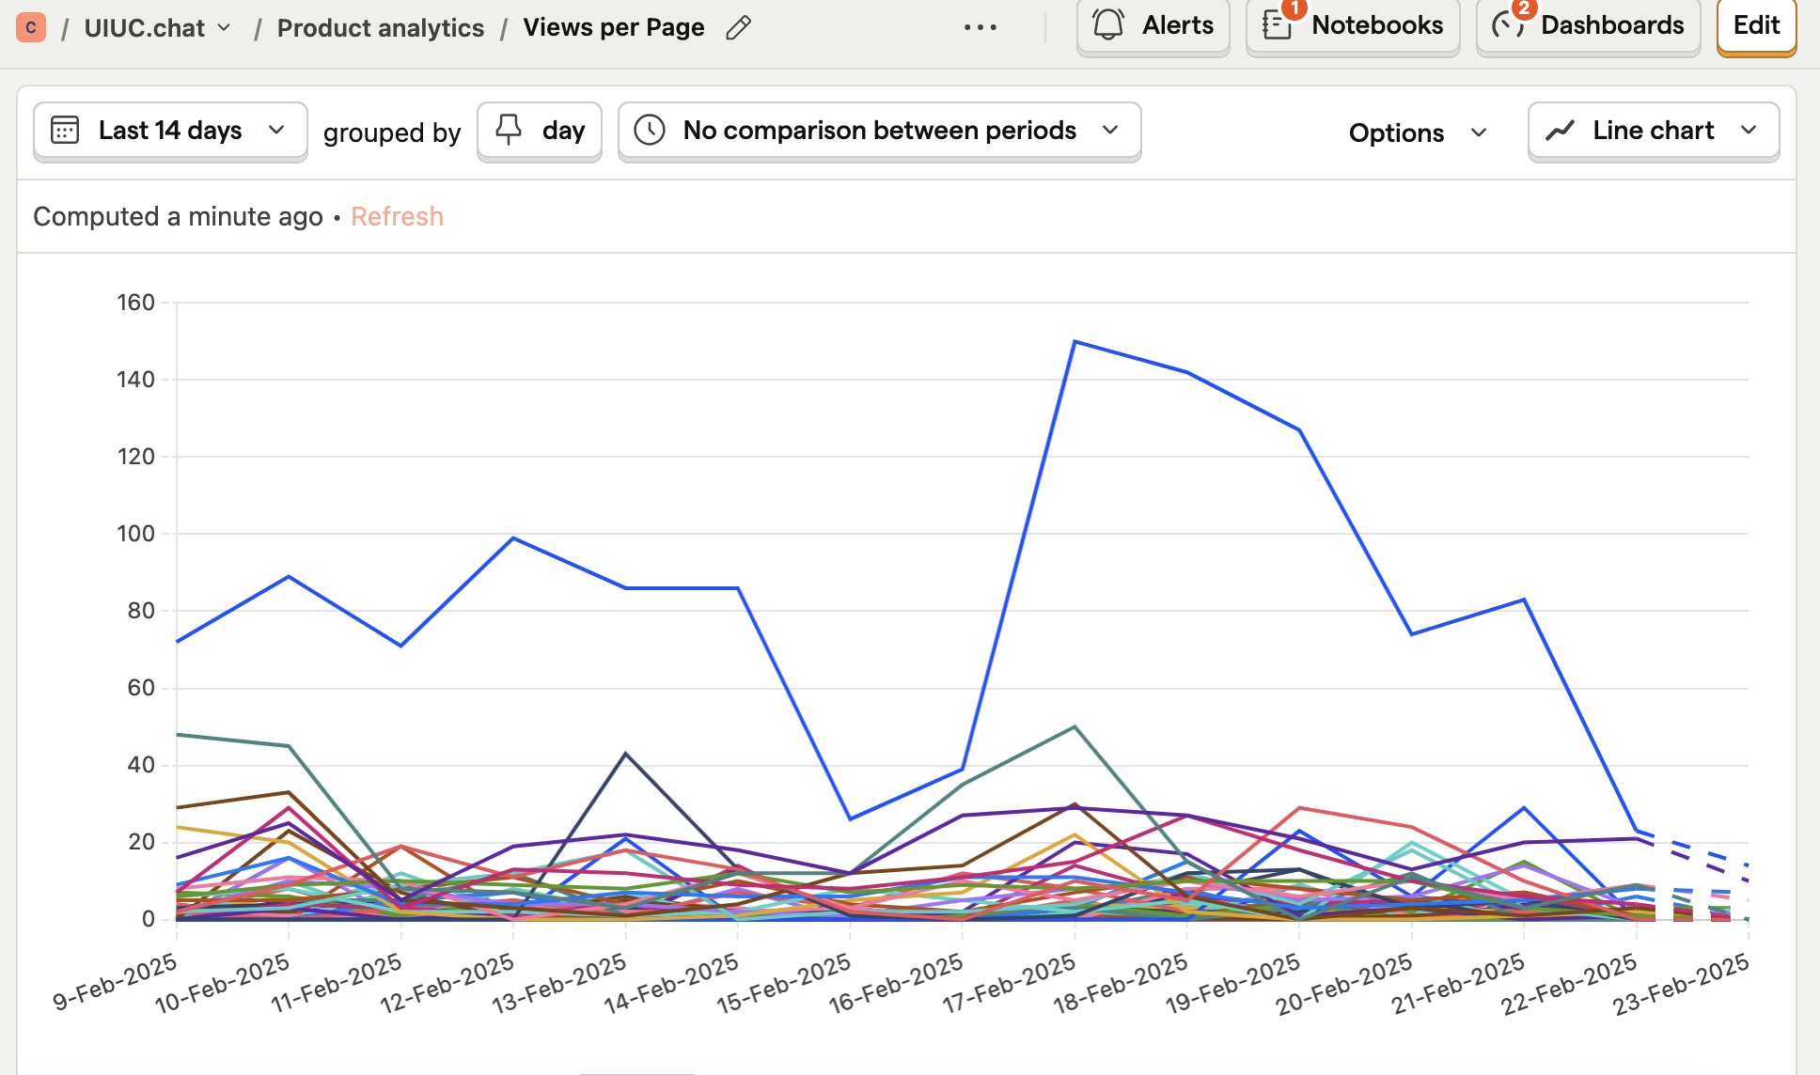Insights:

### **Graph Overview**

The graph tracks the number of views per page on UIUC Chat over the last **14 days**, showing daily traffic trends for various chatbot pages. The y-axis represents the number of views, while the x-axis shows dates from **February 9 to February 23, 2025**. A pop-up on **February 21, 2025**, provides a snapshot of the most visited pages that day, highlighting their respective view counts.

### **Line Representations**

Each line represents a different chatbot page, with the **main homepage (**[**https://uiuc.chat**](https://uiuc.chat/)**)** in blue, having the highest engagement. Other lines represent subject-specific chats such as **PubMed, ECE408SP25, VITA Student Chatbot, and CropWizard**, indicating varied user interest. The **lines fluctuate**, showing peaks and drops, suggesting different usage patterns possibly influenced by **course schedules, deadlines, or promotions**.

### **Calculation of This Metric**

The metric is calculated based on **page views**, which means **each time a user visits a specific chatbot page, it is counted as one view**. PostHog, the analytics tool, aggregates these views over a two-week period, helping track trends, user engagement, and chatbot usage per course or topic.

### **Insights Summary**

The **homepage (83 views)** sees the highest traffic, likely serving as an entry point before users navigate to specific chat pages. **PubMed Chat (29 views)** and **ECE408SP25 Chat (20 views)** indicate strong interest in research and engineering courses, while **VITA Student Chatbot (14 views)** suggests moderate engagement for tax-related inquiries. **CropWizard and ECE120 chats (7-10 views)** show lower engagement, which could be due to lack of awareness or limited relevance at this time. The fluctuating trend suggests **traffic is influenced by academic events or deadlines**, presenting an opportunity to improve engagement through **targeted marketing, integration with course platforms, or in-class promotions**. To enhance usability, further analysis on **return users, time-of-day trends, and drop-off points** would be valuable.

3. Function calling  
  
This dashboard will display a summary of total function calls per function and the respective time periods. It could also show the execution time per function and the users who interact with each function and the frequency.

Insights:  
  
This dashboard can help us identify which features/functionalities users interact with the most or the least in the following ways:  
- Most used functions: help in prioritizing improvements  
- Least used or unutilized applications: help in deciding whether to improve the documentation, remove the function or change the user interface as applicable

- Overall the insights from the dashboard can help us understand user interaction and guide how the application should evolve.  
  
To build this dashboard we need a tracker of how many times a function was invoked. With the current data we can track how many times users interacted with pages/urls but not the functionalities within each of these pages. We would also need to track the execution time for each function and the users’ frequency of interacting with the functions.